### 

### Semester Two Examination, 2019

### Question/Answer booklet

# MATHEMATICS SPECIALIST

**UNIT 2**

## Section Two:

## Calculator-assumed

Your Name

Your Teacher’s Name

## Time allowed for this section

Reading time before commencing work: ten minutes

Working time: one hundred minutes

## Materials required/recommended for this section

***To be provided by the supervisor***

This Question/Answer booklet

Formula sheet (retained from Section One)

***To be provided by the candidate***

Standard items: pens (blue/black preferred), pencils (including coloured), sharpener, correction fluid/tape, eraser, ruler, highlighters

Special items: drawing instruments, templates, notes on two unfolded sheets of A4 paper, and up to three calculators approved for use in this examination

## Important note to candidates

No other items may be taken into the examination room. It is **your** responsibility to ensure that you do not have any unauthorised material. If you have any unauthorised material with you, hand it to the supervisor **before** reading any further.

| **Question** | **Marks** | **Max** | **Question** | **Marks** | **Max** |
| --- | --- | --- | --- | --- | --- |
| **10** |  | **4** | **17** |  | **8** |
| **11** |  | **7** | **18** |  | **5** |
| **12** |  | **6** | **19** |  | **10** |
| **13** |  | **10** | **20** |  | **10** |
| **14** |  | **7** | **21** |  | **12** |
| **15** |  | **5** | **22** |  | **6** |
| **16** |  | **4** |  |  |  |

**Structure of this paper**

| Section | Number of questions available | Number of questions to be answered | Working time (minutes) | Marks available | Percentage of examination |
| --- | --- | --- | --- | --- | --- |
| Section One:  Calculator-free | 9 | 9 | 50 | 52 | 36 |
| Section Two:  Calculator-assumed | 13 | 13 | 100 | 94 | 64 |
|  |  |  |  | **Total** | 100 |

**Instructions to candidates**

1. The rules for the conduct of the Western Australian Certificate of Education ATAR course examinations are detailed in the *Year 12 Information Handbook 2019*. Sitting this examination implies that you agree to abide by these rules.
2. Write your answers in this Question/Answer booklet.
3. You must be careful to confine your answers to the specific questions asked and to follow any instructions that are specific to a particular question.
4. Additional pages for the use of planning your answer to a question or continuing your answer to a question have been provided at the end of this Question/Answer booklet. If you use the space to continue an answer, indicate in the original answer space where the answer is continued, i.e. give the page number.
5. **Show all your working clearly.**Your working should be in sufficient detail to allow your answers to be checked readily and for marks to be awarded for reasoning. Incorrect answers given without supporting reasoning cannot be allocated any marks. For any question or part question worth more than two marks, valid working or justification is required to receive full marks. If you repeat any question, ensure that you cancel the answer you do not wish to have marked.
6. It is recommended that you **do not use pencil**, except in diagrams.
7. The Formula sheet is **not** to be handed in with your Question/Answer booklet.

**See Next Page**

**Section Two: Calculator-assumed (94 Marks)**

This section has **thirteen (13)** questions. Answer **all** questions. Write your answers in the spaces provided.

Spare pages are included at the end of this booklet. They can be used for planning your responses and/or as additional space if required to continue an answer.

● Planning: If you use the spare pages for planning, indicate this clearly at the top of the page.

● Continuing an answer: If you need to use the space to continue an answer, indicate in the original answer space where the answer is continued, i.e. give the page number. Fill in the number of the question that you are continuing to answer at the top of the page.

Working time: 100 minutes.

**Question 10 (4 marks)**



Given the following graph for , state the values of , and   
(all unknowns are **positive** numbers).

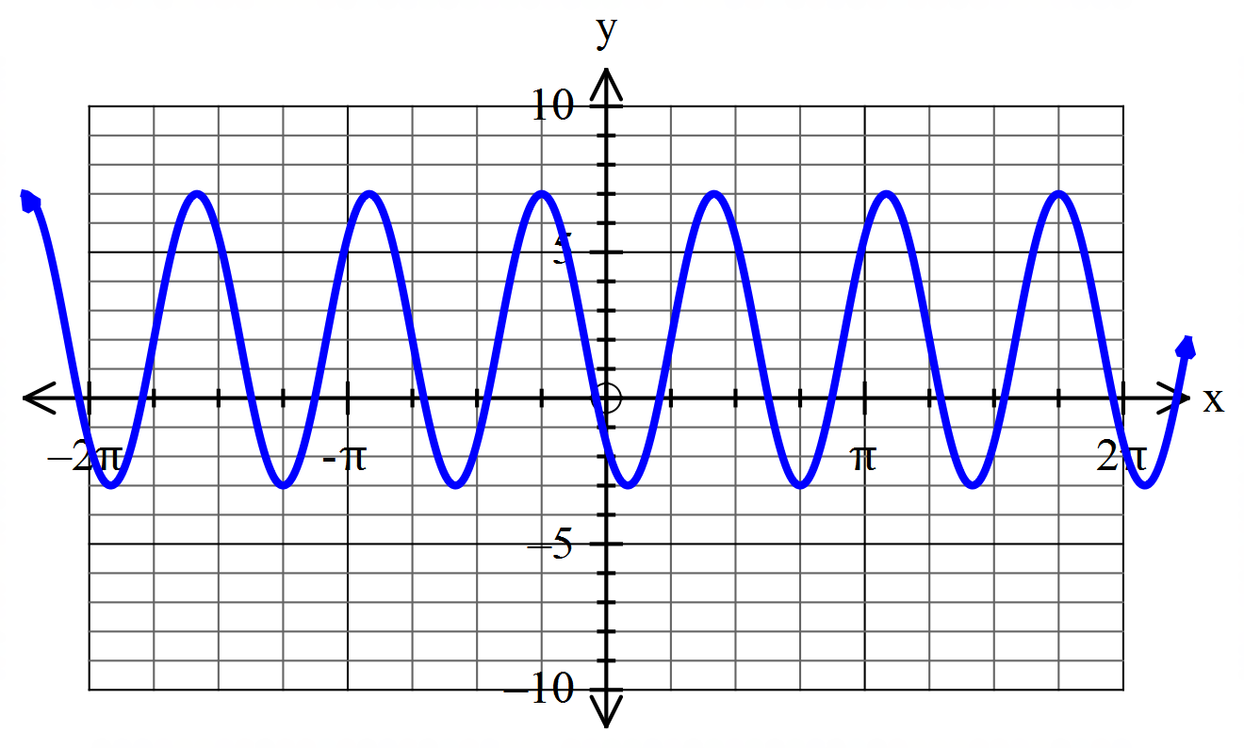

| **Solution** |
| --- |
|  |
| **Specific behaviours** |
| ✔ correct value for  ✔ correct value for  ✔ correct value for  ✔ correct value for |

**Question 11 (7 marks)**



The water depth, metres, measured from the bottom of a lake hours **after 6 am** is modelled by the function

1. Determine the water depth at 12 noon.(2 marks)

| **Solution** |
| --- |
| When , |
| **Specific behaviours** |
| ✔ uses correct value  ✔ states correct answer |

1. Determine the first time (after 6 am) when the water depth is at a maximum.(3 marks)

| **Solution** |
| --- |
| is at a maximum when  This first occurs when , i.e. when .  So the first time is 11 am. |
| **Specific behaviours** |
| ✔ states the condition on the sine function for to be a maximum  ✔ solves for  ✔ states the correct time |

1. Determine the length of time before noon (in hours) when the water depth is less than 8 m.(2 marks)

| **Solution** |
| --- |
| Since , or .  duration = 3 hours |
| **Specific behaviours** |
| ✔ solves for when  ✔ states the duration in hours |

**Question 12 (6 marks)**



Determine the number of four letter “words” (i.e. distinct arrangements of 4 letters) that can be made using the letters of the word FOURTH if:

1. there are no restrictions. (1 mark)

| **Solution** |
| --- |
|  |
| **Specific behaviours** |
| ✔ states |

1. the T and H must be together, in that order, at the start of the word. (2 marks)

| **Solution** |
| --- |
|  |
| **Specific behaviours** |
| ✔ calculates by grouping T and H together  ✔ states correct value |

1. the letters T and H must be together, in any order, anywhere in the word, and there must be at least one vowel in the word. (3 marks)

| **Solution** |
| --- |
|  |
| **Specific behaviours** |
| ✔ writes expression for total number of words with T and H together  ✔ subtracts number of words with T and H together but containing no vowels  ✔ states correct value |

**Question 13 (10 marks)**



Airports and are such that the vector km. A helicopter is to be flown directly from to , and in still air the helicopter can maintain a steady speed of 180km/h. There is a wind blowing with a velocity of km/h.

1. Draw a diagram to represent this information, using to represent the velocity vector the helicopter should set to follow the shortest path from to . (1 mark)

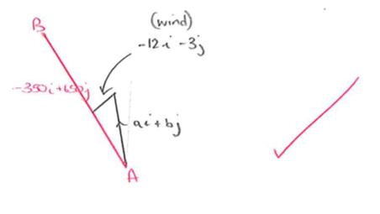

1. Determine the velocity vector defined in part (a) (assuming the wind maintains the same strength and direction for the duration of the journey). Give answers to 2 decimal places. (4 marks)

| **Solution** |
| --- |
| Let the required velocity vector be **.**  Then  Equating coefficients gives  and so  In addition  Solving simultaneously,  and or and  From diagram |
| **Specific behaviours** |
| ✔ equates resultant velocity vector to a **scalar multiple** of displacement vector (or equates a scalar multiple of velocity vector with displacement vector)  ✔ eliminates scalar  ✔ solves simultaneously with equation for square of magnitude of velocity vector  ✔ states correct velocity vector |

1. Calculate the resultant speed of the helicopter, giving your answer to 2 decimal places. (2 marks)

| **Solution** |
| --- |
|  |
| **Specific behaviours** |
| ✔ calculates resultant velocity vector  ✔ states correct speed |

1. Determine to the nearest minute the time it will take for the helicopter to travel from to .

(2 marks)

| **Solution** |
| --- |
|  |
| **Specific behaviours** |
| ✔ calculates distance  ✔ states time to the nearest minute |

1. Assuming the wind maintains the same strength and direction, find, in the form , the velocity vector the pilot should take for the return journey from to , giving answers to 2 decimal places.

(1 mark)

| **Solution** |
| --- |
| Velocity vector = |
| **Specific behaviours** |
| ✔ states correct velocity vector |

**Question 14 (7 marks)**



Of the ten players in the squad for a basketball team, three are primarily guards, two are primarily centres and five are primarily forwards. How many different teams of five could be chosen if:

1. There are no restrictions. (1 mark)

| **Solution** |
| --- |
|  |
| **Specific behaviours** |
| ✔ states correct value |

1. There must be one centre, two forwards and two guards. (2 marks)

| **Solution** |
| --- |
|  |
| **Specific behaviours** |
| ✔ multiplies the numbers of ways of choosing players of each type  ✔ states correct value |

1. There must be at least one guard. (2 marks)

| **Solution** |
| --- |
|  |
| **Specific behaviours** |
| ✔ subtracts number of teams with no guard from total number of teams  ✔ states correct value |

1. There must be at least one guard and no centres. (2 marks)

| **Solution** |
| --- |
|  |
| **Specific behaviours** |
| ✔ subtracts number of teams with no guards and no centres from number with no centres  ✔ states correct value |

**Question 15 (5 marks)**



Prove the following identity:

csc

| **Solution** |
| --- |
|  |
|  |
| **Specific behaviours** |
| ✔ rearranges RHS (or LHS) to obtain LHS (or RHS)  ✔ writes as  ✔ uses double angle formula for or  ✔ divides all terms by  ✔ simplifies to LHS (or RHS) |

**Question 16 (4 marks)**



How many positive integers strictly less than 1000 are divisible by 5, 7, or 9?

| **Solution** |
| --- |
| Number of integers divisible by 5, 7 or 9  = # divisible by 5 + # divisible by 7 + # divisible by 9  – # divisible by – # divisible by – # divisible by  + # divisible by  = 199 + 142 +111 – 28 – 22 – 15 +3  = 390 |
| **Specific behaviours** |
| ✔ uses inclusion/exclusion principle  ✔ demonstrates understanding that (in this case where numbers are pairwise coprime) is divisible by and iff is divisible by .  ✔ correctly counts number of integers in each set  ✔ states correct value |

**Question 17 (8 marks)**



1. Identify the matrix that will rotate points anticlockwise about the origin. (1 mark)

| **Solution** |
| --- |
|  |
| **Specific behaviours** |
| ✔ states correct matrix |

1. Find the image of following a transformation by . (2 marks)

| **Solution** |
| --- |
| Therefore the image of is . |
| **Specific behaviours** |
| ✔ writes point as a column vector and pre-multiplies by  ✔ states correct point |

1. Identify the matrix that represents the single transformation with the same effect as first reflecting in the line and then dilating vertically by a factor of 3. (5 marks)

| **Solution** |
| --- |
| Reflection in line :  Angle of line is .  Hence matrix is  Dilation vertically by factor 3 is  Therefore |
| **Specific behaviours** |
| ✔ identifies angle of line of reflection  ✔ determines reflection matrix  ✔ determines dilation matrix  ✔ multiplies in correct order to obtain  ✔ states correct matrix |

**Question 18 (5 marks)**



1. Simplify the following expressions into their simplest factorial form. (2 marks)

| **Solution** |
| --- |
|  |
| **Specific behaviours** |
| ✔ factorises numerator  ✔ states correct answer |

1. Prove that

(3 marks)

| **Solution** |
| --- |
|  |
| **Specific behaviours** |
| ✔ correctly factorises numerator of LHS  ✔ cancels  ✔ simplifies to obtain RHS |

**Question 19 (10 marks)**



Two perpendicular lines are each tangent to a circle of radius 1 at points and . The centre of the circle is .

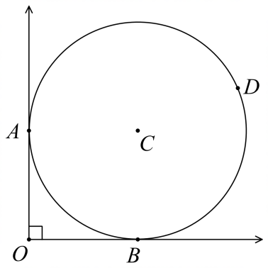

a) Prove that . (3 marks)

| **Solution** |
| --- |
| (Given)  (Tangent and radius to point of intersection are perpendicular)  (sum of angles in a quadrilateral is ). |
| **Specific behaviours** |
| ✔ states that  ✔ states with reason that  ✔ concludes with reason that |

b) Prove that . (2 marks)

| **Solution** |
| --- |
| (Tangents to common point have equal length)  is isosceles ()  (angles in a triangle add to ) |
| **Specific behaviours** |
| ✔ states with reason that  ✔ states that is isosceles or uses calculation to justify that |

c) Point lies on the circle such that . Find the distance as an **exact value**.

(5 marks)

| **Solution** |
| --- |
| (angle at centre is twice angle at circumference) OR (alternate segment theorem)  (Pythagoras’ Theorem)  (sine rule) |
| **Specific behaviours** |
| ✔ calculates that  ✔ states with reason that  ✔ determines length  ✔ uses sine rule  ✔ obtains correct value for |

**Question 20 (10 marks)**



1. If and determine
2. (1 mark)

| **Solution** |
| --- |
|  |
| **Specific behaviours** |
| ✔ correct value for scalar product |

1. the angle between the vectors and , to the nearest tenth of a degree.

(2 marks)

| **Solution** |
| --- |
|  |
| **Specific behaviours** |
| ✔ correct expression for scalar product with cos  ✔ states angle |

1. the scalar projection of on . (2 marks)

| **Solution** |
| --- |
|  |
| **Specific behaviours** |
| ✔ correct expression for scalar projection  ✔ states value |

1. The vector has a magnitude of 35 and is perpendicular to the vector

. Determine the values of the constants and, where . (5 marks)

| **Solution** |
| --- |
|  |
| **Specific behaviours** |
| ✔ uses magnitude to form an equation for m  ✔ calculates values of  ✔ uses scalar product equal to zero  ✔ calculates values of  ✔ chooses correct pairing |

**Question 21 (12 marks)**



1. Solve the matrix equation , where and , to determine the matrix . (4 marks)

| **Solution** |
| --- |
|  |
| **Specific behaviours** |
| ✔ factorises  ✔ determines and  ✔ pre-multiplies by  ✔ determines |

1. Let and . Determine the value of if . (3 marks)

| **Solution** |
| --- |
|  |
| **Specific behaviours** |
| ✔ determines and  ✔ writes equation for  ✔ correct value for |

1. Preimage is transformed by the single matrix to Image .

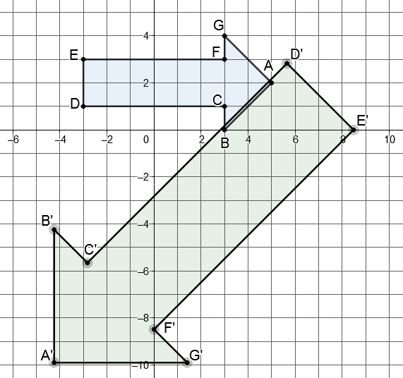

1. Given and , determine the matrix . (2 marks)

| **Solution** |
| --- |
|  |
| **Specific behaviours** |
| ✔ writes matrix equation  ✔ determines |

1. Find the area of the Image . (3 marks)

| **Solution** |
| --- |
| Area of Preimage =  Area of Image |
| **Specific behaviours** |
| ✔ correct area of preimage  ✔ correct  ✔ correct area of image |

**Question 22 (6 marks)**



Three forces act on an object at point such that the system is in equilibrium. These forces are represented with vectors as shown in the diagram, where is acute. Determine the values of and , giving answers to 2 decimal places.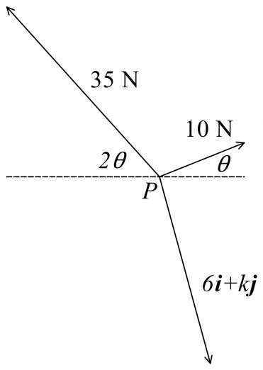

| **Solution** |
| --- |
| or  Since is acute, and |
| **Specific behaviours** |
| ✔ writes equation for equilibrium state  ✔ equates components  ✔ uses double angle formula and obtains quadratic equation in  ✔ solves for and obtains correct value for  ✔ equates components  ✔ solves for |

**END OF QUESTIONS**

**Additional working space**

Question number:

**Additional working space**

Question number:

**Additional working space**

Question number: